Biomedical Question Answers

1. What is Biomedical Img Processing ?Explain with a block diagram

Ans>

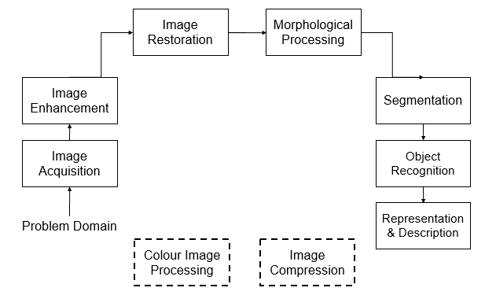

1. Image Acquisition

This is the first step or process of the fundamental steps of digital image processing. Image acquisition could be as simple as being given an image that is already in digital form. Generally, the image acquisition stage involves per-processing, such as scaling, etc.

2. Image Enhancement

mage enhancement is among the simplest and most appealing areas of digital image processing. Basically, the idea behind enhancement techniques is to bring out detail that is obscured, or simply to highlight certain features of interest in an image. Such as changing brightness & contrast, etc.

3. Image Restoration

Image restoration is an area that also deals with improving the appearance of an image. However, unlike enhancement, which is subjective, image restoration is objective, in the sense that restoration techniques tend to be based on mathematical or probabilistic models of image degradation.

4. Color Image Processing

Color image processing is an area that has been gaining its importance because of the significant increase in the use of digital images over the Internet. This may include color modeling and processing in a digital domain etc.

5. Wavelets and Multiresolution Processing

Wavelets are the foundation for representing images in various degrees of resolution. Images subdivision successively into smaller regions for data compression and for pyramidal representation.

6. Compression

Compression deals with techniques for reducing the storage required to save an image or the bandwidth to transmit it. Particularly in the uses of the internet, it is very much necessary to compress data.

7. Morphological Processing

Morphological processing deals with tools for extracting image components that are useful in the representation and description of shape.

8. Segmentation

Segmentation procedures partition an image into its constituent parts or objects. In general, autonomous segmentation is one of the most difficult tasks in digital image processing. A rugged segmentation procedure brings the process a long way toward a successful solution of imaging problems that require objects to be identified individually.

9. Representation and Description

Representation and description almost always follow the output of a segmentation stage, which usually is raw pixel data, constituting either the boundary of a region or all the points in the region itself.

Choosing a representation is only part of the solution for transforming raw data into a form suitable for subsequent computer processing.

Description deals with extracting attributes that result in some quantitative information of interest or are basic for differentiating one class of objects from another.

10. Object recognition

Recognition is the process that assigns a label, such as, vehicle to an object based on its descriptors.

2>Explain EM spectrum

Ans>

**In electromagnetic spectrum**, the entire distribution of [electromagnetic radiation](https://www.britannica.com/science/electromagnetic-radiation) is according to [frequency](https://www.britannica.com/science/frequency-physics) or [wavelength](https://www.britannica.com/science/wavelength).

Although all electromagnetic waves travel at the [speed of light](https://www.britannica.com/science/speed-of-light) in a vacuum, they do so at a wide range of frequencies, wavelengths, and [photon](https://www.britannica.com/science/photon) energies.

The electromagnetic [spectrum](https://www.britannica.com/science/spectrum) [comprises](https://www.merriam-webster.com/dictionary/comprises) the span of all electromagnetic radiation and consists of many subranges, commonly referred to as portions, such as visible light or ultraviolet radiation

. The various portions has different names based on differences in behaviour in the emission, transmission, and [absorption](https://www.britannica.com/science/absorption-physics) of the corresponding waves and also based on their different practical applications.

There are no precise accepted boundaries between any of these [contiguous](https://www.merriam-webster.com/dictionary/contiguous) portions, so the ranges tend to overlap.

The entire electromagnetic spectrum, from the lowest to the highest frequency (longest to shortest wavelength), includes all radio waves (e.g., commercial [radio](https://www.britannica.com/technology/radio-technology) and [television](https://www.britannica.com/technology/television-technology), [microwaves](https://www.britannica.com/science/microwave-radiation), [radar](https://www.britannica.com/technology/radar)), [infrared radiation](https://www.britannica.com/science/infrared-radiation), visible [light](https://www.britannica.com/science/light), [ultraviolet radiation](https://www.britannica.com/science/ultraviolet-radiation), [X-rays](https://www.britannica.com/science/X-ray), and [gamma rays](https://www.britannica.com/science/gamma-ray). Nearly all frequencies and wavelengths of electromagnetic radiation can be used for [spectroscopy](https://www.britannica.com/science/spectroscopy).

3>What is Resolution Compare different Resolution

Ans>

The term image resolution is applied to digital images, film images, and other types of images and it describes the details that an image holds.

resolution refers to the level of detail to which a ground feature can be described and mapped.

Image resolution can be measured in various ways like spatial, spectral, temporal and radiometric.

Based on these parameters image resolution is categorised into following four types:

• spatial resolution – it refers to variations in the reflectance or emittance determined by the shape, size and texture of the target

• spectral resolution – it refers to the changes in the reflectance or emittance as a function of wavelength

• temporal resolution – it involves seasonal changes in reflectance or emittance

• radiometric resolution – it includes changes in the polarisation of the radiation reflected or emitted by an object.

4>Explain DCT, DWT, HOUGH ,transforms

Ans:

DCT (Discrete cosine transform): The discrete cosine transform (DCT) is used to separate the image in to pixel. DCT is used in signal, image processing especially for lossy compression because it has a strong energy compaction. The lossy image compression ratio of the image was good in number. But the outcome of the image was not good

DWT (Discrete wavelet transforms) :Dwt is used to separate the image into a pixel. The DWT represents the two images representing the technique to transform the DWT process. Then the DWT image will move on to the quantization process. That the process is doing again and again to get the best result. Thus the output of the DWT image compression is good. The PSNR value is also good in compression ratio. The quality of the DWT image is also good.

The Hough transform: is a technique which can be used to isolate features of a particular shape within an image. Because it requires that the desired features be specified in some parametric form, the classical Hough transform is most commonly used for the detection of regular curves such as lines, circles, ellipses, etc. A generalized Hough transform can be employed in applications where a simple analytic description of a feature(s) is not possible.

5>Explain Biological Neural Network

Ans:

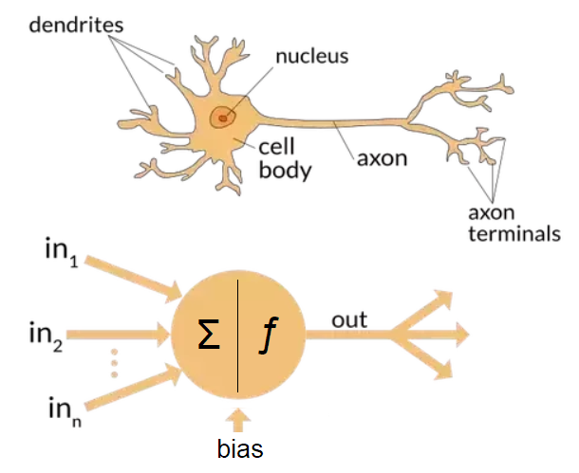

Biological Neural Network (BNN) is a structure that consists of Synapse, dendrites, cell body, and axon. In this neural network, the processing is carried out by neurons. Dendrites receive signals from other neurons, Soma sums all the incoming signals and axon transmits the signals to other cells.

**Some advantages of BNN :**

* The synapses are the input processing element.
* It is able to process highly complex parallel inputs.
* Information is distributed into the network throughout into sub-nodes, even if it gets corrupted it can be retrieved.

**Some disadvantages of BNN :**

* There is no controlling mechanism.
* Speed of processing is slow being it complex.
* There is no control unit to monitor the information being processed into the network.

6>Compare and contrast AI,DL and ML

Ans:

**1. Artificial Intelligence (AI)**

Humans have been obsessed with automation since the beginning of technology adoption. AI enables machines to think without any human intervention. It is a broad area of computer science. AI systems fall into three types: ANI: Artificial Narrow Intelligence, which is goal-oriented and programmed to perform a single task. AGI (Artificial General Intelligence) which allows machines to learn, understand, and act in a way that is indistinguishable from humans in a given situation. ASI (Artificial Super Intelligence) is a hypothetical AI where machines are capable of exhibiting intelligence that surpasses brightest humans.  
  
**2. Machine Learning (ML)**  
ML is a subset of AI that uses statistical learning algorithms to build smart systems. The ML systems can automatically learn and improve without explicitly being programmed. The recommendation systems on music and video streaming services are examples of ML. The machine learning algorithms are classified into three categories: supervised, unsupervised and reinforcement learning.  
  
**3. Deep Learning (DL)**  
This subset of AI is a technique that is inspired by the way a human brain filters information. It is associated with learning from examples. DL systems help a computer model to filter the input data through layers to predict and classify information. Deep Learning processes information in the same manner as the human brain. It is used in technologies such as driver-less cars. DL network architectures are classified into Convolutional Neural Networks, Recurrent Neural Networks, and Recursive Neural Networks.

9>What are Limitations of ANN?

Ans

1. Hardware Dependence:
   1. Artificial Neural Networks require processors with parallel processing power, by their structure.
   2. For this reason, the realization of the equipment is dependent.
2. Unexplained functioning of the network:
   1. This the most important problem of ANN.
   2. When ANN gives a probing solution, it does not give a clue as to why and how.
   3. This reduces trust in the network.
3. Assurance of proper network structure:
   1. There is no specific rule for determining the structure of artificial neural networks.
   2. The appropriate network structure is achieved through experience and trial and error.
4. The difficulty of showing the problem to the network:
   1. ANNs can work with numerical information.
   2. Problems have to be translated into numerical values before being introduced to ANN.
   3. The display mechanism to be determined will directly influence the performance of the network.
5. The duration of the network is unknown:
   1. The network is reduced to a certain value of the error on the sample means that the training has been completed.
   2. The value does not give us optimum results.

10>Emphasize on Deep Learning.

Ans

Deep Learning ,is a type of Machine Learning, inspired by the structure of a human brain. Deep learning algorithms attempt to draw similar conclusions as humans would by continually analyzing data with a given logical structure. To achieve this, deep learning uses a multi-layered structure of algorithms called neural networks.

The individual layers of neural networks can also be thought of as a sort of filter that works from gross to subtle, increasing the likelihood of detecting and outputting a correct result.

The human brain works similarly. Whenever we receive new information, the brain tries to compare it with known objects. The same concept is also used by deep neural networks.